Ethernet standard and specification

Q1. Draw a simple diagram showing the pin layout of an RJ-45 connector and label the colour codes for the T568A and T568B Ethernet wiring standards.
Ans.
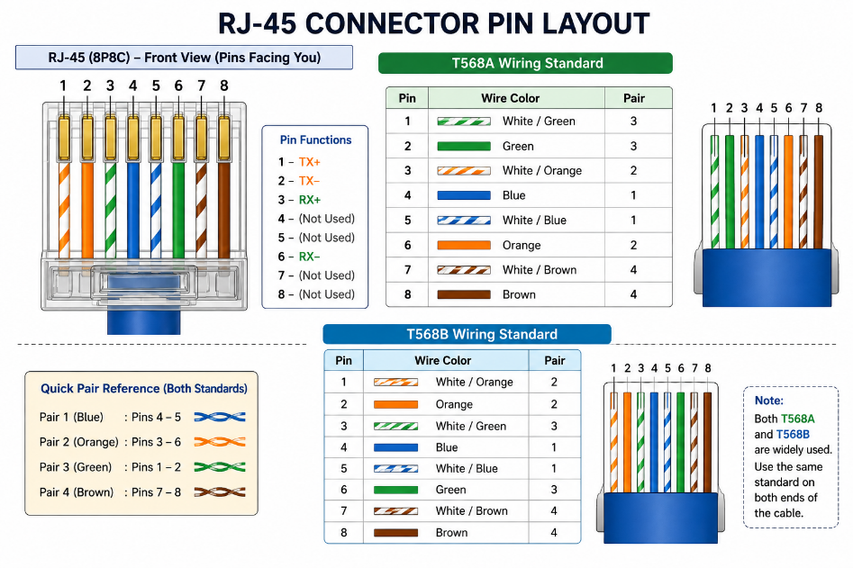
Q2. Create a table comparing the key specifications of Ethernet standards 10BASE-T, 100BASE-TX, and 1000BASE-T, including speed, cable type, maximum cable length, and connector type.
Ans.
Ethernet Standard | Speed | Cable Type | Maximum Cable Length | Connector Type
10BASE-T | 10 Mbps | Cat3 or better twisted-pair cable | 100m | RJ-45
100BASE-TX | 100 Mbps | Cat5 or better twisted-pair cable | 100m | RJ-45
1000BASE_T | 1 Gbps (1000 Mbps) | Cat5e or Cat6 twisted-pair cable | 100m | RJ-45

Q3. Given a scenario where you need to connect two laptops directly using Ethernet, explain which cable (straight-through or crossover) you would use and why. Hint: Think about how transmit and receive pairs are wired in each cable type.
Ans. To connect two laptops directly using Ethernet, traditionally you would use a crossover cable.
A crossover cable swaps the transmit (TX) and receive (RX) wire pairs so that the transmit pins of one laptop connect to the receive pins of the other laptop.
A straight-through cable is normally used to connect different types of devices, such as a laptop to a switch or router.
Note: Most modern laptops support Auto-MDI/MDIX, so a normal straight-through cable often works too.
Q4. List three real-world devices in your home or college that use Ethernet connections, and for each, specify the likely Ethernet standard (e.g., 100BASE-TX, 1000BASE-T) they support.
Ans.
Device | Likely Ethernet Standard | Speed
Wi-Fi Router | 1000BASE-T | Up to 1 Gbps
Desktop Computer / College Lab PC | 1000BASE-T | Up to 1 Gbps
Network Printer | 100BASE-TX | Up to 100 Mbps

- These are common examples. Newer routers and computers usually support Gigabit Ethernet (1000BASE-T), while many printers still use Fast Ethernet (100BASE-TX).

